**Name:** Meet Vipul Gandhi

**PRN:** 2020BTECS00112

**Class:** Final Year (Computer Science and Engineering)

**Year:** 2023-24 **Semester:** 1

**Course:** High Performance Computing Lab

**Practical No. 6**

**Title of practical: Implementation of OpenMP programs.**

Implement following Programs using OpenMP with C:

1. Implementation of Prefix sum.
2. Implementation of Matrix-Vector Multiplication.

**Problem Statement 1:** Implementation of Prefix sum.

**Screenshots:**

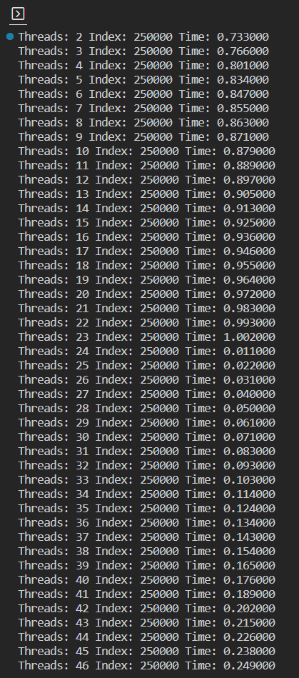

**Information:**

**Analysis:**



**Problem Statement 2:** Implementation of Matrix-Vector Multiplication.

**Screenshots:**

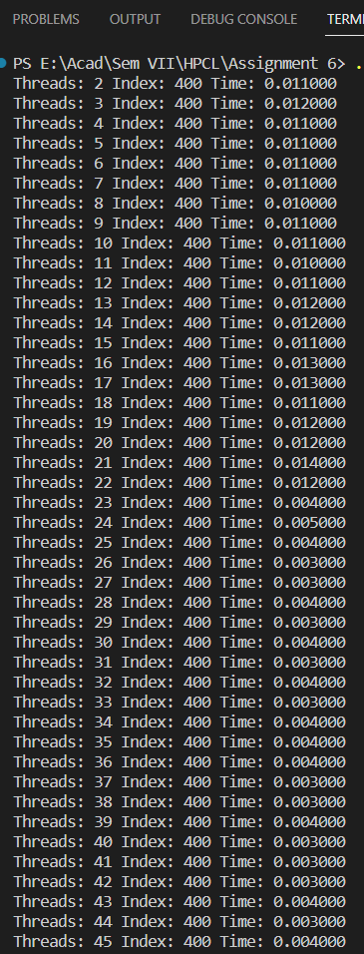

**Information:**

**Analysis:**



**GitHub Link:** <https://github.com/meetgandhi692/HPC-Lab/tree/5ba5368c99d35186e97c9284188f2b6142dca912/Assignment%206>